Project Design Phase-II
Technology Stack (Architecture & Stack)

Date | 06/02/2026
Team ID | LTVIP2026TMIDS83275
Project Name | Deep Learning Fundus Image Analysis for Early Detection of Diabetic Retinopathy
Maximum Marks | 4 Marks

Technical Architecture:
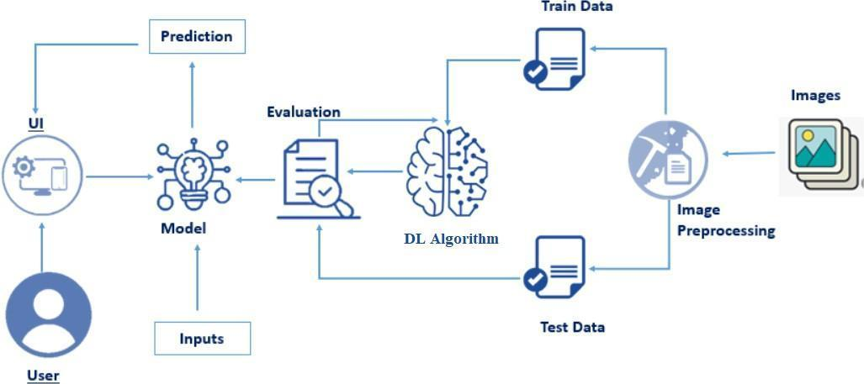
Table-1 : Components & Technologies:
S.No | Component | Description | Technology
1. | User Interface | Web-based interface where users upload retinal fundus images and view prediction results | HTML, CSS, Bootstrap
2. | Application Logic-1 | Backend logic for handling image upload, request routing, and response rendering | Python, Flask
3. | Application Logic-2 | Image preprocessing logic (resize to 224x224, normalization, array conversion) | Python, NumPy, OpenCV
4. | Application Logic-3 | Deep learning model loading and prediction logic | TensorFlow, Keras
5. | Database | No structured database used; prediction results processed in real-time | Not Applicable (Stateless Processing)
6. | Cloud Database | No cloud database integrated; system does not store patient data | Not Applicable
7. | File Storage | Temporary storage of uploaded images during runtime | Local File System (uploads/ folder)
8. | External API-1 | No external API currently integrated | Not Applicable
9. | External API-2 | Future scope: Integration with hospital management systems or medical APIs | Not Implemented (Future Scope)
10. | Machine Learning Model | Classifies retinal images into diabetic retinopathy severity levels | Convolutional Neural Network (CNN) – TensorFlow/Keras
11. | Infrastructure (Server / Cloud) | Application deployment and hosting environment | Local System (Flask Development Server), Railway Cloud Deployment, Gunicorn

Table-2: Application Characteristics:
S.No | Characteristics | Description | Technology
1. | Open-Source Frameworks | The application is built using open-source frameworks for backend development and machine learning model implementation | Python, Flask, TensorFlow, Keras, NumPy
2. | Security Implementations | The system validates input image formats, prevents invalid file uploads, and does not store personal patient data. Basic secure coding practices followed | Flask request validation, File type validation, Python secure handling, HTTPS (Cloud deployment)
3. | Scalable Architecture | The system follows a modular client-server architecture (Presentation Layer – Application Layer – Model Layer). The ML model can be replaced or upgraded independently | Flask (Backend Layer), CNN Model (ML Layer), Railway Cloud Deployment
4. | Availability | The application can be deployed on a cloud platform for 24/7 availability. Cloud hosting ensures remote accessibility | Railway Cloud Platform, Gunicorn WSGI Server
5. | Performance | The system is optimized for real-time inference. Image resizing and normalization reduce computational load. Model inference time < 3 seconds | TensorFlow/Keras optimized model, NumPy preprocessing, CPU-based inference

